

Pocket Pet

Handling Manual

|  |
| --- |
| Kathy Maxwell  01/06/2022  Revisions: Shelby Reich  Updated: 02/24/2022  *The material within this manual was created and written for the sole use of Helping Hands Humane Society. Copies, recreations or use of any material within this manual requires written permission of the* Executive Director of Helping Hands Humane Society. |

**Table of Contents**

Section 1: Introduction 4

Overview 4

Contacts 4

Section 2: Policies and Rules 5

Animal Handling Policy 5

Pocket Pet Handling Policy 5

Kennel Cards 5

Section 3: Common Pocket Pets 6

Rabbit Handling and Care 6

General Handling 9

Rabbit Rules and Policies 9

9

Guinea Pig Handling and Care 9

Guinea Pig Body Language and Vocalizations 9

General Handling 10

Guinea Pig Rules and Policies 11

Ferret Handling and Care 11

Ferret Body Language and Vocalizations 11

General Handling 12

Ferret Rules and Policies 12

Section 4: Special Pocket Pets 12

Overview 12

Rat Handling and Care 13

Rat Body Language and Vocalizations 13

General Handling 13

Rat Rules and Policies 13

Chinchilla Handling and Care 14

Chinchilla Body Language and Vocalizations 14

General Handling 14

Chinchilla Rules and Policies 14

Sugar Glider Handling and Care 15

Sugar Glider Body Language and Vocalizations 15

General Handling 15

Section 5: Off-Limit Pocket Pets 16

Overview 16

Alternative Interactions 16

Section 6: Safety and Health 16

Overview 16

Personal Risk 17

Environmental Factors 17

Contagion and Disease Management 17

Emergencies 19

Section 7: Conclusion 19

# Section 1: Introduction

## Overview

This manual’s purpose is to provide the necessary information for proper and safe pocket pet handling. Volunteers are an essential part of Helping Hands Humane Society and what it accomplishes! HHHS structures its programs to best suit our mission and needs. It is also fundamental to the program that all safety concerns and needs are met. We want to provide the utmost care for any animal who comes through our doors as an organization. One of the many ways we accomplish this is by providing education and training to our community, staff, and volunteers. The primary goal is to provide the best care for any pocket pet during their stay. Thank you for choosing to volunteer with our animals.

## Contacts

For all questions and concerns surrounding the HHHS dog handling program, please contact:

Shelby Reich, Volunteer Coordinator

[shelbyr@hhhstopeka.org](mailto:shelbyr@hhhstopeka.org)

785-233-7325 ext.103

Other animal care contacts:

Lindsay Roth, Behavior Specialist

lindsaymhhhs@gmail.com

785-233-7325 ext.104

Margaret Price, Manager of Admissions/Kennel Staff

[margaretp@hhhstopeka.org](mailto:margaretp@hhhstopeka.org)

785-233-7325 ext.117

# Section 2: Policies and Rules

## Animal Handling Policy

It is expected that all HHHS volunteers treat all animals with care, compassion, and respect. It is also required that before handling any animal a volunteer takes the corresponding training. Volunteers are not to take any animal from the shelter without approval from HHHS staff. While we understand that volunteers have the best of intentions, it is ultimately the responsibility of the staff to make policy and procedure decisions concerning the shelter and the animals in our care.

## Pocket Pet Handling Policy

There are 3 different categories of Pocket Pets at HHHS, Common Pocket Pets, Special Pocket Pets, and Off-Limit Pocket Pets. To handle any Pocket Pet you must have first taken the corresponding class. This class specifically covers how to handle Common Pocket Pets. To handle Special Pocket Pets, you must have special authorization from Lindsay or Margaret. Off-Limit Pocket Pets are not to be handled at any time unless specifically instructed by Lindsay or Margaret.

## Kennel Cards

Every animal at HHHS has a kennel card and an Identification Number. The ID number is used to keep track of the animal in our online database. The kennel card is one of the first places you should start when trying to find out information about an animal. It should also be checked before removing an animal from their kennel. In addition to the kennel cards other important signs can be found at the front of their kennel, like “Under Adoption Process” or “Under Vet Care”, both of which signals you to leave a dog in their kennel.

1. Animals Name
2. Animal ID Number for Shelter Buddy, which is the online database that the shelter uses to track the animals under our care.
3. The status of the animal (this is sometimes not up to date on the paper version and can be a past status of the animal.)
4. Current location- Kennel Number and Kennel location
5. The date that an animal was admitted into the shelter
6. 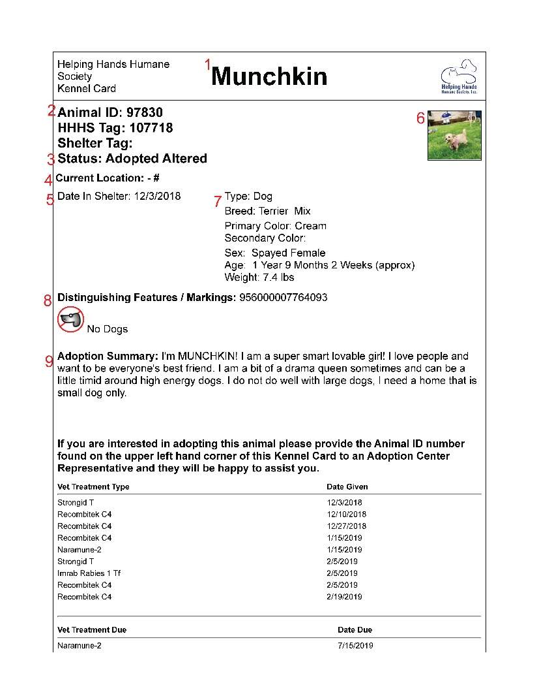Photo of the animal (Every animal at our shelter has some type of identification photo to help distinguish them from similar-looking animals.)
7. This information is about breed, weight, and age (age is the number one thing that you should look for because if an animal is under 6 months they cannot go outside)
8. This is where you will find restrictions for adoptions, like no dogs, no cats, or no small children. This can help you determine the best time and area to socialize with a dog.
9. This is a summary of the animal’s adoption profile that can tell you a little about their behavior, preferences, and personality

# Section 3: Common Pocket Pets

Rabbits, guinea pigs, and ferrets are some of the most common pocket pets that we see at Helping Hands Humane Society. The Pocket Pet Handling class covers the rules and policies for all pocket pets, but it also covers more in-depth how to handle and interact with these three small mammals.

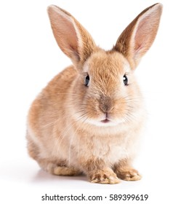

## Rabbit Handling and Care

Rabbits are fairly social creatures and with over 30 species worldwide they come in many shapes and sizes. They naturally burrow in their natural habitat and you may see them do the same when they are domesticated. At HHHS we sterilize all of our rabbits, this is for several reasons. The first is that it helps with the overpopulation of rabbits in our community. It also helps prevent some diseases and typically doubles their life span. Rabbits can make great family pets, so our main purpose when handling rabbits at HHHS is to help socialize them and get them more accustomed to human interaction.

*Body Language and Vocalizations*

* **Thumping**: This involves a rabbit pounding on the floor with their back legs and it is seen as a warning signal. It can signal that they are feeling:
  + Stressed
  + Anxious
  + Sensing danger
* **Flopping**: This is when a rabbit falls or flips onto their side or stomach. This normally means that they are happy or content
* **Tense body, upright tail, laid back ears/ Lunging**: This tense body posture is one of the ways a rabbit tells us to back off.
* **Tooth grinding**: There are two types of tooth grinds in rabbits
  + Soft tooth grinding: this almost sounds like purring and is a way that a rabbit signal that they are content or happy.
  + Loud tooth grinding/ clicking: this can indicate a more serious issue and a concern form should be filled out for the rabbit.
* **Circlin**g: This behavior is most often seen when a rabbit wants attention.
* **Chinning**: This is when a rabbit rubs their chin on people or things. A rabbit’s scent glands are located on the underneath of their chin and this is one of the ways they mark their territory.
* **Licking**: when a rabbit licks you it is their way of showing affection

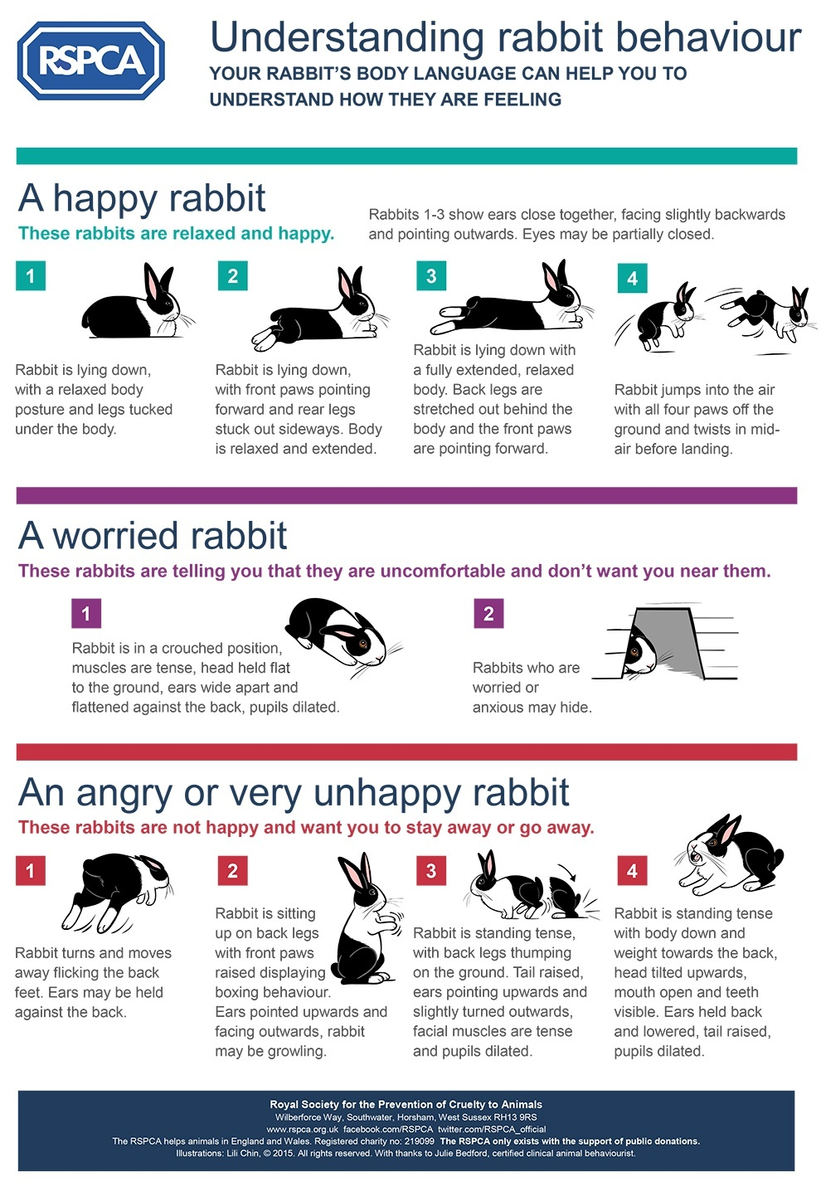

### General Handling

The best method to pick up a rabbit is to cradle them against your body using your arm to support them from underneath. Use one of your hands to hold their two back feet to help them feel more supported.

*Key Notes*

* Do not pick up a rabbit if you feel uncomfortable doing so.
* Do not scruff the rabbit.
* Make sure that you give the rabbit time to adjust to you (by petting them) before you pick them up.

### Rabbit Rules and Policies­­

1. Rabbits are allowed to roam in the pocket pet room
   1. The door must be closed
   2. No other animals are allowed out at the same time unless authorized by Margaret or Lindsay.
   3. The rabbit must be supervised at all times.
2. To transport a rabbit anywhere outside of the pocket pet room they must be secured in a pet taxi.
3. Always trust your instincts.

## Guinea Pigs - Testicles - Fries - Rocky Mountain Oysters - 1 Set

## Guinea Pig Handling and Care

Guinea pigs are very social creatures. They are herd animals that are native to South America. Domesticated guinea pigs are no longer found in the wild, but they have cousins, that closely resemble them that are still undomesticated. Guinea pigs typically live 6 to 8 years and can make great family pets.

### Guinea Pig Body Language and Vocalizations

**Popcorning**: This is when they hop straight up and down. This usually signals that they are happy, excited, or feeling playful

**Freezing**: This normally means that a guinea pig is feeling frightened or is unsure about something.

**Strutting**: Moving side to side of stiff legs, can also be accompanied by teeth chattering and can be a sign of aggression.

**Teeth Chattering:** This is typically a sign of aggression and a way that they tell people to back off.

**Hissing:** This is one of the sounds that a guinea pig makes when they are upset.

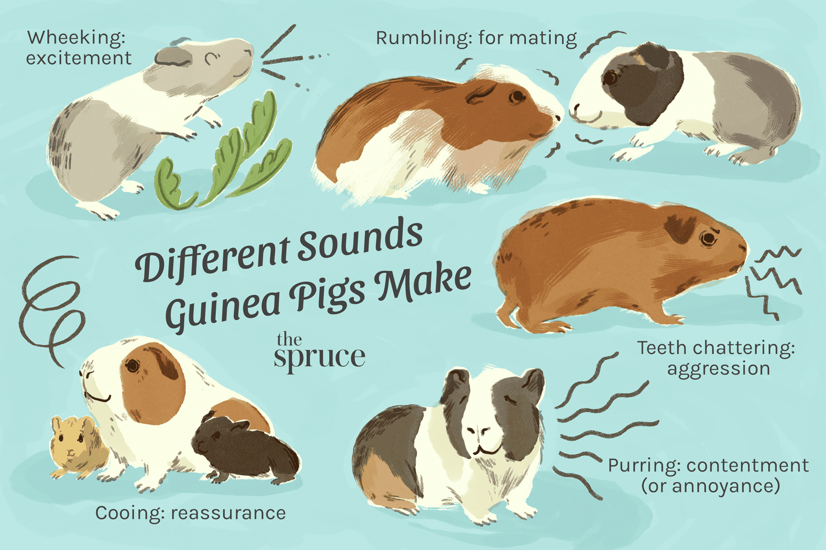**Wheeking:** This sounds like a loud squeal or whistle and can show that they are excited or wants attention.

### General Handling

1. Approach guinea pig *from the front*
2. Gently *talk* to them and *stroke* them on the head
3. Place one hand *under their chest* (just behind the front feet) and use your other hand to *support its hindquarters*
4. Bring them *against your chest* (this position should feel most secure), still supporting them by using two hands
5. Keep a firm grip, but do not squeeze (their bones and internal organs are fragile)
6. If your they begin to struggle, lower yourself down to the floor in order to reduce the chance of fall injuries

*Note: Guinea pigs’ backs are fragile, so do not bend them backward*

### Guinea Pig Rules and Policies­­

1. Guinea Pigs are allowed to roam in the pocket pet room
   1. The door must be closed
   2. No other animals are allowed out at the same time unless authorized by Margaret or Lindsay.
   3. The guinea pig must be supervised at all times.
2. To transport a guinea pig anywhere outside of the pocket pet room they must be secured in a pet taxi.
3. Guinea Pigs are not to be put into balls or allowed to use tunnels, exercise wheels, or tubing.
4. Always trust your instincts

## Ferrets for Sale: Live Pet Ferrets for Sale | PetcoFerret Handling and Care

Ferrets are small animals apart of the weasel family. They have a long history of domestication making them good pets and like rabbits and guinea pigs, are very social creatures and can benefit from human interaction. Ferrets are seen as a more controversial pet as they are illegal as pets in several states including California, Hawaii, and the district of Columbia, while a few other states have stricter regulations on them.

### Ferret Body Language and Vocalizations

**Jumping, Wagging, and Dancing:** This is often seen when ferrets are feeling happy and playful.

**Dooking:** This is a term for the clucking-like noise that they make when they are happy.

**Hissing:** This signals that they are stressed, angry, or scared

**Poofed-out tail:** This most commonly happens when a ferret is stressed out.

**Barking or whimpering:** This is how they signal that they are upset.

**Honking:** this is a sign that a ferret might be nervous, but it can also show that they are curious.

### General Handling

Although ferrets are one of the larger small mammals it is still important to handle them with care to help prevent injury. The way we recommend handling a ferret is to:

1. Place one hand around or under the ferret’s chest
2. Lift and support the ferret’s hind legs with your other hand
3. Hold the ferret close to your body

### Ferret Rules and Policies­­

1. Ferrets are allowed to roam in the pocket pet room
   1. The door must be closed
   2. No other animals are allowed out at the same time unless authorized by Margaret or Lindsay.
   3. The ferret must be supervised at all times.
2. To transport a ferret anywhere outside of the pocket pet room they must be secured in a pet taxi.
3. Always trust your instincts

# Section 4: Special Pocket Pets

## Overview

Special Pocket Pets is the term we use to describe pocket pets that take additional training and authorization before you are allowed to handle them. Rats, chinchillas, and sugar gliders are the three mammals that require you to talk with Margaret or Lindsay before you are permitted to handle them.

**\*You must be authorized before you can handle these animals\***

## Rats for Sale | Live Pet Rats for Sale | PetcoRat Handling and Care

Rats are pack animals who can be well socialized depending on their previous owners. They, like many other rodents, have teeth that grow their entire life leading them to chew on more items in their environment as compared to other pocket pets. They are often confused with mice, but there are several key differences. One is that they are bigger than the typical mouse. The other key difference is that they have a hairless tail and a mouse’s tail will have hair on it.

### Rat Body Language and Vocalizations

* **Chattering/Bruxing:** This sounds similar to a cat’s purr and it is when a rat grinds their teeth together. They do this when they are happy.
* **Ears Forward:** This is another way that a rat shows that they are happy or content.
* **Hunched Back:** When a rat stiffens their shoulders and hindquarters and draws them into their body it is showing that the rat is fearful or defensive.
* **Tail Swishing:** This is when a rat rattles or flicks their tail back and forth. This is another sign that they are becoming aggressive or might be fearful.
* **Puffed Up Fur:** This is another sign of aggression.

### General Handling

1. Place one hand around their chest area
2. Lift them supporting their hind feet with your other hand
3. Hold them close to your body

Another option for picking them up is to:

1. Place your hands on either side of them
2. Scoop them up into your palms
3. Keep them close to your body

### Rat Rules and Policies­­

1. Large rats are allowed to roam in the pocket pet room
   1. The door must be closed
   2. No other animals are allowed out at the same time unless authorized by Margaret or Lindsay.
   3. The rat must be supervised at all times.
2. To transport a rat anywhere outside of the pocket pet room they must be secured in a pet taxi.
3. Always trust your instincts

## Chinchilla Handling and Care

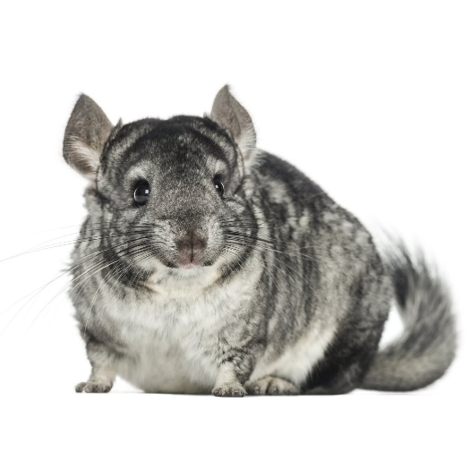 Chinchillas are native to the Andes mountain range in Chile and Peru and are a member of the rodent family. They are more delicate when it comes to handling them and that is why we require special authorization to be able to handle them.

### Chinchilla Body Language and Vocalizations

* **Standing upright and still:** This typically signals that they are alert but curious.
* **Hopping and Jumping:** This signals they are happy, excited, or want to play.
* **Puffed fur:** This normally means that they are fearful or might become aggressive.
* **Repetitive Movements:** This can show that they are bored and want more attention.
* **Somersaulting:** This is a common sign of anxiety.

### General Handling

1. Place one hand under or around their chest
2. Lift them supporting their hind kegs
3. Hold them close to your body
4. Make sure you keep them upright to help protect their spine

**It is important to handle them carefully because if they are handled improperly or become too frightened it might lead to fur slip. Fur slip is a natural instinct for escape, chinchillas will lose patches of fur in order to get away from something they are afraid of. In severe cases, they can even lose their tail, which will never grow back.

### Chinchilla Rules and Policies­­

1. Chinchillas are allowed to roam in the pocket pet room
   1. The door must be closed
   2. No other animals are allowed out at the same time unless authorized by Margaret or Lindsay.
   3. The chinchilla must be supervised at all times.
2. To transport a chinchilla anywhere outside of the pocket pet room they must be secured in a pet taxi.
3. Always trust your instincts

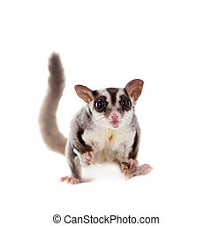

## Sugar Glider Handling and Care

Although rare, we have housed sugar gliders in the past. Sugar gliders are naturally nocturnal animals, meaning that it is not uncommon to see them asleep throughout the entire day. If they happen to be awake while you are volunteering, then you can interact with them. Sugar gliders, as it says in their name, are able to glide through the air. In the shelter environment, this can make them more difficult to handle, which is why we require volunteers to have authorization before handling them.

### Sugar Glider Body Language and Vocalizations

* **Barking:** The pitch of a sugar glider’s bark is more high pitch, but like a dog, it is one of the ways that they communicate both good and bad things.
* **Crabbing:** This is a sound sometimes described as sounding like a swarm of locusts. They use this as a way to show that they are frightened.
* **Sneezing:** Sugar gliders have a unique way of grooming themselves and sneezing helps them spit saliva into their hands so they can groom themselves.
* **Shaking:** This is one of the ways that they show that they are anxious.

### General Handling

1. Put your hands on either side of their body
2. Scoop them, surrounding them with your hands
3. Keep them close to your body

*Sugar Gliders Rules and Policies­­*

1. Sugar gliders are allowed to roam in the pocket pet room
   1. The door must be closed
   2. No other animals are allowed out at the same time unless authorized by Margaret or Lindsay.
   3. The sugar glider must be supervised at all times.
2. To transport a sugar glider anywhere outside of the pocket pet room they must be secured in a pet taxi.
3. Always trust your instincts

# Section 5: Off-Limit Pocket Pets

## Overview

All of the pocket pets that are off-limits can make great pets, but it is the best practice of our shelter to not handle these animals. There are several reasons for this, but the main ones are the capability and likelihood of the animal to get loose and run away, the safety of volunteers because many of these animals are prone to biting, and the safety of the animal. These are the animals that are included in HHHS off-limit section:

* Gerbils
* Hamsters
* Mice
* Hedge Hogs
* Birds
* Amphibians
* Reptiles

## Alternative Interactions

All of the off-limit animals still get daily enrichment, handed out by staff, to help combat boredom, but there are still other ways you can interact with them, without touching them. The number one way we suggest to interact with them is by reading to them. This helps them socialize and become accustomed to human interaction.

# Section 6: Safety and Health

## Overview

The first priority when handling any animal is personal safety and health. The second consideration is the health and safety of the animal and the animals around them. This means that numerous things have to be considered before handling an animal including:

* Personal Risk
* Environmental factors
* Contagion and Disease Management

## Personal Risk

When handling any animal at the shelter it is first important to take an evaluation of yourself. This step requires a volunteer to be aware of one’s ability and limitations and choose to handle an animal to handle that fits within that range. This helps not only reduce the risk of personal injury, but it also helps reduce the risk of injury of people and animals around you.

## Environmental Factors

Environmental factors are something that an animal handler must be aware of at all times. It can include a wide variety of things depending on where you are handling an animal at. Some of the main things to be aware of are:

* Tripping Hazards (like slippery floors)
* Inclement Weather
* People and Animals Around you

The best way to handle any environmental factor is to be aware of potential hazards and to know and voice your plan confronted with them.

## Contagion and Disease Management

THANK YOU for volunteering your time and talents to help make our shelter more like home for our amazing animals! There are a few important things to remember about the shelter and our animals; there are a large number of animals in a fairly small space, and our animals come in with completely unknown medical histories. This makes disease prevention key in the health of our animals--and you are a part of that too!

Zoonotic illnesses are diseases humans can get from animals. Many infectious diseases can spread from animals to people, and some of these can come from your pet. Know that getting diseases from a pet is pretty uncommon and that you can prevent most of them with some very simple steps.

**The most important thing you can do to help prevent the spread of disease is to wash your hands! Wash them thoroughly and between each animal.**

The most common way diseases are spread in an animal shelter is via fomites. Fomites are inanimate objects that can carry diseases. Most common fomites: dog dishes, toys, beds, bedding, human hands, shoes, cell phones, door handles and clothing. Some important steps for you take (other than washing your hands!): Have a specific pair of shoes that you only wear to the shelter, change your clothes as soon as you get home, and disinfect your cell phone, keys, car door knobs/steering wheel with bleach wipes.

It is important to understand that you can not only spread disease within the shelter, but you can spread disease to your animals at home. Make sure your animals are up-to-date on their vaccines. Don’t let them jump on, kiss, or sniff your clothing or shoes after being at the shelter. If you are concerned about your animals, please take them to your regular veterinarian for assistance.

Some zoonotic diseases are:

**Rabies:** Caused by a virus and spread through bites, rabies is a disease that affects the nervous system and is generally fatal. Although rabies can be spread from pets such as a dog or cat, you are more likely to get it from a wild animal. Tell the Volunteer Coordinator immediately if an animal bites you.

**Toxoplasmosis**: You are most likely to get toxoplasmosis from eating partially cooked meat or from contact with animal feces while gardening, but you can also get it from contact with contaminated cat feces. It is a protozoan organism; if you are pregnant or getting ready to become pregnant, it is particularly important to be aware of this disease.

**Hookworms and roundworms:** These are intestinal parasites routinely found in dogs and cats, particularly kittens and puppies. The worms’ eggs or larvae are passed from pets through stool. You can pick them up through your skin from walking barefoot, playing outside, or handling feces and not washing your hands.

**Tapeworm:** Most human tapeworm infections arise from ingestion of contaminated meats. However, children can pick up tapeworm parasites from cats and dogs by accidentally swallowing a flea infected with tapeworm larvae. Tapeworm segments may show up in stool or around the anal area on a pet or human; they look like grains of rice. The single most important control for tapeworms is to control fleas on your pet and in the environment.

**Ringworm:** Not really a worm, ringworm is caused by a fungal infection within the top layer of the skin. It is very contagious and dogs, cats, horses, other animals, and humans can pass ringworm. On skin, ringworm causes a ring-shaped, reddish rash that may be dry and scaly or wet and crusty. It may also be itchy. Although it's difficult to prevent, ringworm responds well to self-care and treatment. It is estimated that 30% of cats are subclinical carriers of ringworm, meaning they have the fungus on them but are not showing any signs or symptoms.

**Thank you for all you do!** Written by Dr. Jami Grace, HHHS’s Veterinarian 2-19-2016

## Emergencies

*Bites*

Although uncommon bites do happen and should be immediately reported. When a dog bite happens at the shelter it does not mean that the dog is going to be euthanized, but is important to report, because the dog gets put on a two-week quarantine to make sure that they are not a carrier of any diseases. If you do get bitten there is a bite wash kept in a couple of areas of the shelter that can help prevent the development of any infection.

# Section 7: Conclusion

Any of the material covered in this manual can be changed at any time to suit the needs of the shelter. If there are any questions concerning any material covered please contact Shelby Reich the Volunteer Coordinator.

**Thank you for choosing to volunteer with our pocket pets!**